**VBSX_Validator_v1.1.2**

**November 2013**

**Copyright (c) Tushar Sharma | www.testoxide.com**

**About VBSX_Validator_v1.1.2**

The VBSX-Validator is a VB Script and MSXML based command line tool that allows you to validate large XML files against a given XSD Schema. In this case the XML File to be validated does not require to be rendered on a GUI client such as 'XML Copy Editor' or 'Altova XML Spy'. Hence the tool is particularly targeted for validating heavy / large XML files which otherwise may have issues while opening with other GUI tools.

**Architecture/Flow**

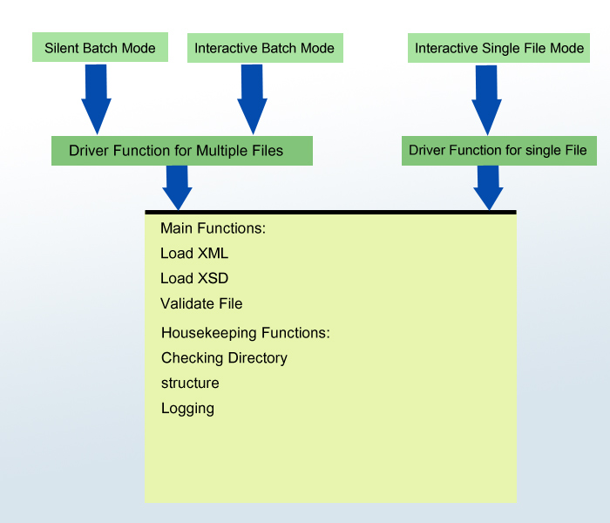

VBSX_Validator_v1.1.2 can be reached at:

Voice: (contact No.)

Website:www.testoxide.com

Email-ID:projects@testoxide.com